Low-Level Design (LLD) — Warranty / Chargeable Module
Attribute | Value
Module | Warranty / Chargeable (System Config Master)
Menu path | ADMINISTRATION → Warranty / Chargeable
Landing page | warranty_chargeable.php
Application | Complaint / Dealer Portal
Stack (target) | Core PHP + MySQL (PDO)
Stack (current repo) | Core PHP + PostgreSQL via PDO
Document version | 1.0
Access | System Admin only (role id 6) — no RBAC module slug
Architecture | Shared SCM stack ($scmType = 'warranty_chargeable')

â”€â”€â”€â”€â”€â”€â”€â”€â”€â”€â”€â”€â”€â”€â”€â”€â”€â”€â”€â”€â”€â”€â”€â”€â”€â”€â”€â”€â”€â”€â”€â”€

1. Module Overview

1.1 Purpose
System Administrators maintain warranty / chargeable type options in warranty_chargeable_types for Service Log and Spare Parts Capture. The module is a thin SCM wrapper: list/create/edit/details/soft-delete share system_config_master_* pages, helpers, APIs, and JS. Consumers store the selected name string (not an FK id).

1.2 Scope
In scope | Out of scope
List / Add / Edit / Details / Soft-delete | Installed Base master field (no IB column)
Active / Inactive status | Complaint master field (no complaint column)
Case-insensitive name uniqueness | Hard delete
Create abuse / rate-limit guard | Cascading rename/delete to SL / SP rows
Active names for Service Log & Spare Parts Select2 | Other SCM types (Industry Segment, Part Replaced, etc.)

1.3 High-level architecture
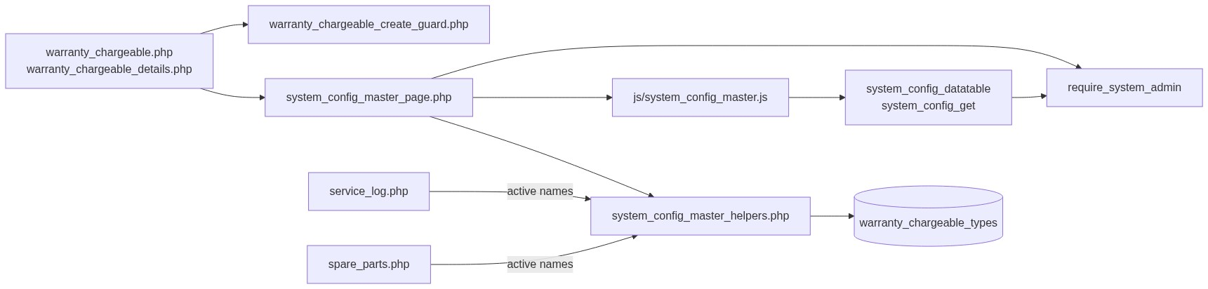
Figure 1 — High-level architecture
â”€â”€â”€â”€â”€â”€â”€â”€â”€â”€â”€â”€â”€â”€â”€â”€â”€â”€â”€â”€â”€â”€â”€â”€â”€â”€â”€â”€â”€â”€â”€â”€

2. Functional Requirements
ID | Requirement | Priority
FR-01 | System Admin can open Warranty / Chargeable list (DataTables) | Must
FR-02 | Create type with name and status | Must
FR-03 | Edit via inline slide-down form | Must
FR-04 | Soft-delete; hide from list | Must
FR-05 | Unique name among non-deleted (case/trim-insensitive) | Must
FR-06 | Filter / search list; status active/inactive | Should
FR-07 | View read-only details + audit fields | Should
FR-08 | Throttle / rate-limit create requests | Should
FR-09 | Client validate.js for name + status | Should
FR-10 | Expose active names to Service Log and Spare Parts | Must

â”€â”€â”€â”€â”€â”€â”€â”€â”€â”€â”€â”€â”€â”€â”€â”€â”€â”€â”€â”€â”€â”€â”€â”€â”€â”€â”€â”€â”€â”€â”€â”€

3. User Roles & Permissions

3.1 RBAC module slug
None. Warranty / Chargeable administration is gated by System Admin (SYSTEM_ADMIN_ROLE = 6), not a permission slug.

3.2 Permission matrix
Capability | Gate
All Warranty / Chargeable admin pages | require_system_admin($obconn) (via SCM page)
SCM APIs with type=warranty_chargeable | admin_api_require_system_admin
Denied | Access denied. System Admin privileges required.

Pages (warranty_chargeable.php, warranty_chargeable_details.php, delete_warranty_chargeable.php) are in rbac_admin_pages() and skip module RBAC; System Admin check is authoritative.

3.3 Page / API mapping
Resource | Gate
warranty_chargeable.php | System Admin
warranty_chargeable_details.php | System Admin
delete_warranty_chargeable.php | System Admin
api/system_config_datatable.php?type=warranty_chargeable | System Admin API
api/system_config_get.php?type=warranty_chargeable | System Admin API

3.4 Consumer access
Service Log / Spare Parts users need their module permissions (separate). They only see active, non-deleted names via scm_get_active_names('warranty_chargeable') (wrappers: service_log_warranty_types(), spare_parts_warranty_types()).
â”€â”€â”€â”€â”€â”€â”€â”€â”€â”€â”€â”€â”€â”€â”€â”€â”€â”€â”€â”€â”€â”€â”€â”€â”€â”€â”€â”€â”€â”€â”€â”€

4. Business Rules
ID | Rule
BR-01 | Soft-deleted rows excluded from list, get, uniqueness, and consumer options.
BR-02 | Name unique among non-deleted: LOWER(TRIM(name)); edit excludes self.
BR-03 | Soft-deleted names may be reused on create (partial unique index).
BR-04 | Status must be active or inactive.
BR-05 | Inactive names stay in admin list but are not offered in SL / SP dropdowns.
BR-06 | Soft-delete / rename does not update existing service_logs / spare_parts_consumption values.
BR-07 | No “in use” check before soft-delete.
BR-08 | Create-only abuse guard: max 1/request; min 3s interval; max 20 creates / 15 min.
BR-09 | Edit requires existing non-deleted row.
BR-10 | created_by = current_username() on insert; created_at / updated_at timestamps.
BR-11 | Details/delete URL ids are base64_encode((string) id).
BR-12 | Create/update stay on page (no PRG). Delete redirects to list with session flash.
BR-13 | Consumers store the name string, not warranty_chargeable_types.id.
BR-14 | SCM type key is warranty_chargeable; table warranty_chargeable_types; submit key submit_warranty_chargeable.
BR-15 | Master name max 100; consumer columns are VARCHAR(50) — keep option names ≤ 50 for safe storage.

â”€â”€â”€â”€â”€â”€â”€â”€â”€â”€â”€â”€â”€â”€â”€â”€â”€â”€â”€â”€â”€â”€â”€â”€â”€â”€â”€â”€â”€â”€â”€â”€

5. Database Design

5.1 ER diagram
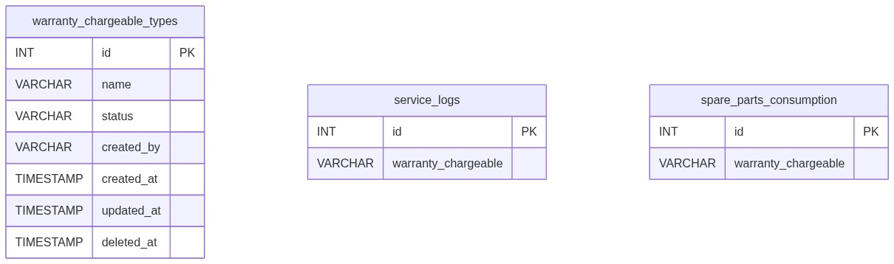
Figure 2 — Entity relationship diagram
Logical link (name string, not FK):
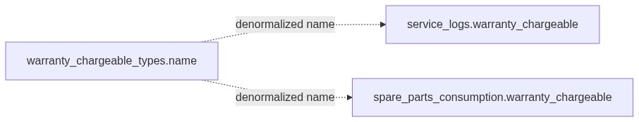
Figure 3 — Denormalized name link to Service Log / Spare Parts

5.2 Table: warranty_chargeable_types
Column | MySQL type | Notes
id | INT UNSIGNED AUTO_INCREMENT | PK
name | VARCHAR(100) | Required; unique among non-deleted
status | VARCHAR(20) | active / inactive; default active
created_by | VARCHAR(100) | Creator username
created_at | TIMESTAMP | Insert
updated_at | TIMESTAMP NULL | Update / soft-delete
deleted_at | TIMESTAMP NULL | Soft-delete

Indexes (current repo): PK on id; partial unique on lower(trim(name)) WHERE deleted_at IS NULL; index on deleted_at.

5.3 Related tables
Table | Column | Role
service_logs | warranty_chargeable VARCHAR(50) | Service Log consumer
spare_parts_consumption | warranty_chargeable VARCHAR(50) | Spare Parts consumer

5.4 Reference / lookup sources
Source | Usage
scm_registry()['warranty_chargeable'] | Labels, pages, table, submit key
rbac_status_options() | Status <select>
scm_get_active_names('warranty_chargeable') | SL / SP dropdowns
service_log_warranty_types() / spare_parts_warranty_types() | Consumer wrappers

â”€â”€â”€â”€â”€â”€â”€â”€â”€â”€â”€â”€â”€â”€â”€â”€â”€â”€â”€â”€â”€â”€â”€â”€â”€â”€â”€â”€â”€â”€â”€â”€

6. API / Backend Design

6.1 Page endpoints
Endpoint | Method | Auth | Description
warranty_chargeable.php | GET | System Admin | List + Add/Edit panel
warranty_chargeable.php | POST submit_warranty_chargeable | System Admin | Create or update
warranty_chargeable_details.php?id= | GET | System Admin | Read-only details
delete_warranty_chargeable.php?id= | GET | System Admin | Soft-delete

Wrappers set $scmType = 'warranty_chargeable' and include shared SCM templates.

6.2 JSON APIs

POST api/system_config_datatable.php
Body/query includes type=warranty_chargeable. Server-side DataTables over warranty_chargeable_types where deleted_at IS NULL.
{
"draw": 1,
"recordsTotal": 10,
"recordsFiltered": 2,
"data": [{ "id": "#1", "name": "...", "status": "...", "actions": "<html>" }]
}

GET api/system_config_get.php?type=warranty_chargeable&id=
Returns row for edit form population. System Admin API gated.

6.3 Supporting lookup APIs
N/A for admin UI. Service Log / Spare Parts (and IB nested modals) load active names server-side into Select2 options. Prefill APIs may copy sl.warranty_chargeable into Spare Parts forms.

6.4 Core PHP responsibilities
File | Role
warranty_chargeable.php | Create-guard hook + $scmType wrapper
includes/system_config_master_page.php | Shared list/form POST handler
includes/system_config_master_details_page.php | Shared details
includes/system_config_master_delete.php | Shared soft-delete
includes/system_config_master_helpers.php | Registry, validate, CRUD, options
includes/module_create_guards/warranty_chargeable_create_guard.php | Create throttle / rate limit
includes/admin_access_helpers.php | System Admin gate

â”€â”€â”€â”€â”€â”€â”€â”€â”€â”€â”€â”€â”€â”€â”€â”€â”€â”€â”€â”€â”€â”€â”€â”€â”€â”€â”€â”€â”€â”€â”€â”€

7. Validation Rules

7.1 Server-side (scm_validate + uniqueness + create guard)
Field / rule | Message
Name empty | Warranty / Chargeable name is required.
Name > 100 | Warranty / Chargeable name cannot exceed 100 characters.
Status missing/invalid | Status is required.
Duplicate name | Warranty / Chargeable name already exists. Please choose a different name.
Missing edit target | Warranty / Chargeable not found or already deleted.
Create throttle | Please wait a few seconds before creating another record.
Rate limit | Create rate limit exceeded. You may create up to 20 records every 15 minutes...
Bulk payload | Too many records in a single request. A maximum of 1 record(s)...

Consumers (Service Log / Spare Parts): Warranty / Chargeable is required. / Invalid Warranty / Chargeable selection.

7.2 Client-side (js/system_config_master.js)
â€¢ validate.js: Name required + max 100; Status required (generic wording, not label-prefixed)
â€¢ Edit load failure: Failed to load record details.
â€¢ Success alert fades after 3s
â€¢ Status is native <select> (no Select2 on master)
â”€â”€â”€â”€â”€â”€â”€â”€â”€â”€â”€â”€â”€â”€â”€â”€â”€â”€â”€â”€â”€â”€â”€â”€â”€â”€â”€â”€â”€â”€â”€â”€

8. UI Screen Specifications

8.1 Listing — warranty_chargeable.php
Element | Spec
Subtitle | Manage warranty and chargeable type options.
Placeholder | e.g. Warranty
CTA | Add Warranty / Chargeable / Cancel (#scmFormCard)
Grid | #scmTable — ID, Name, Status, Created At, Action
List title | Warranty / Chargeable Types List
Actions | View / Edit / Delete (confirm('Delete this record?'))
Icon | bi-shield-check

8.2 Form panel
Fields: Name*, Status* (active / inactive).
Hidden: record_id, submit_warranty_chargeable, SCM type wiring via scm_page_js_config.

8.3 Details — warranty_chargeable_details.php
Name, status badge, created by, created/updated timestamps (shared record-details layout).

8.4 Modals / Select2
â€¢ No CRUD modals on master.
â€¢ Admin: native status select — no Select2.
â€¢ Consumers: Select2 on #serviceLogWarrantySelect, #sparePartsWarrantySelect, #slSparePartsWarrantySelect, #ibServiceLogWarrantySelect (as applicable).
â”€â”€â”€â”€â”€â”€â”€â”€â”€â”€â”€â”€â”€â”€â”€â”€â”€â”€â”€â”€â”€â”€â”€â”€â”€â”€â”€â”€â”€â”€â”€â”€

9. Database Flow

9.1 Create
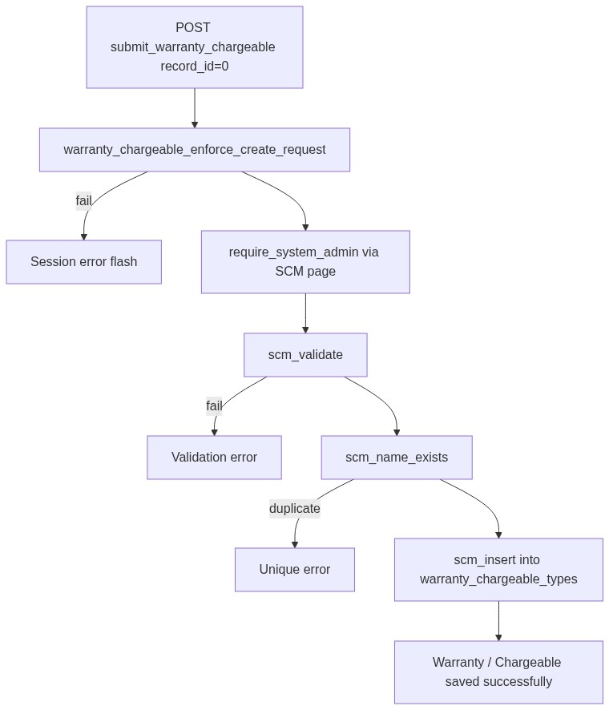
Figure 4 — Create database flow

9.2 Soft-delete
UPDATE warranty_chargeable_types
SET deleted_at = CURRENT_TIMESTAMP,
updated_at = CURRENT_TIMESTAMP
WHERE id = :id
AND deleted_at IS NULL;

9.3 Active options for consumers
SELECT name
FROM warranty_chargeable_types
WHERE deleted_at IS NULL
AND status = 'active'
ORDER BY created_at ASC, id ASC;
â”€â”€â”€â”€â”€â”€â”€â”€â”€â”€â”€â”€â”€â”€â”€â”€â”€â”€â”€â”€â”€â”€â”€â”€â”€â”€â”€â”€â”€â”€â”€â”€

10. Sequence Diagram

10.1 Create warranty / chargeable type
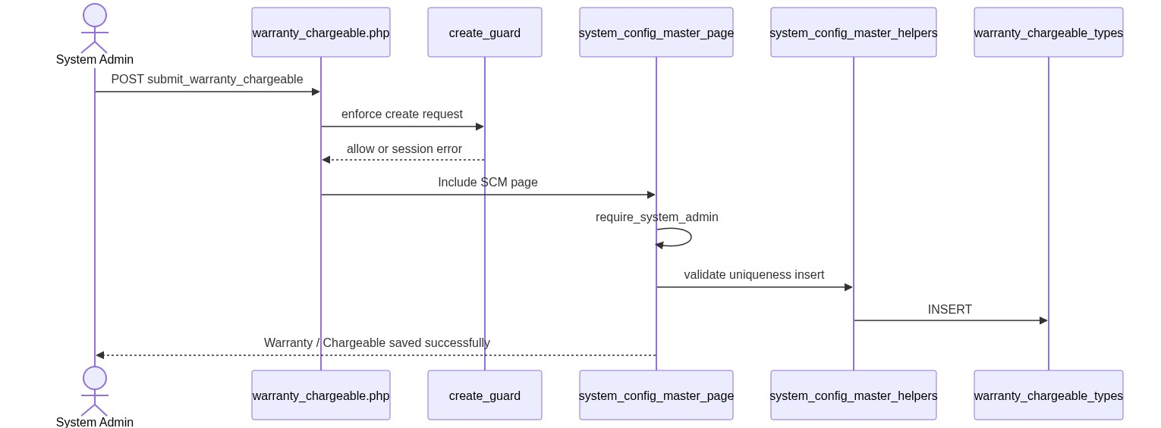
Figure 5 — Sequence: Create warranty / chargeable type

10.2 Soft-delete and consumer impact
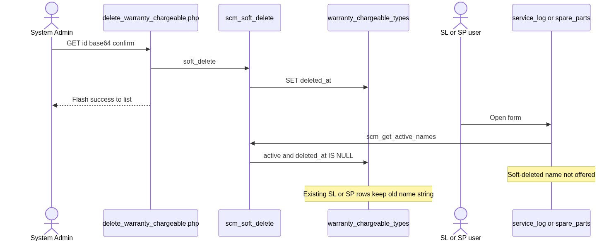
Figure 6 — Sequence: Soft-delete and consumer impact
â”€â”€â”€â”€â”€â”€â”€â”€â”€â”€â”€â”€â”€â”€â”€â”€â”€â”€â”€â”€â”€â”€â”€â”€â”€â”€â”€â”€â”€â”€â”€â”€

11. Activity Diagram
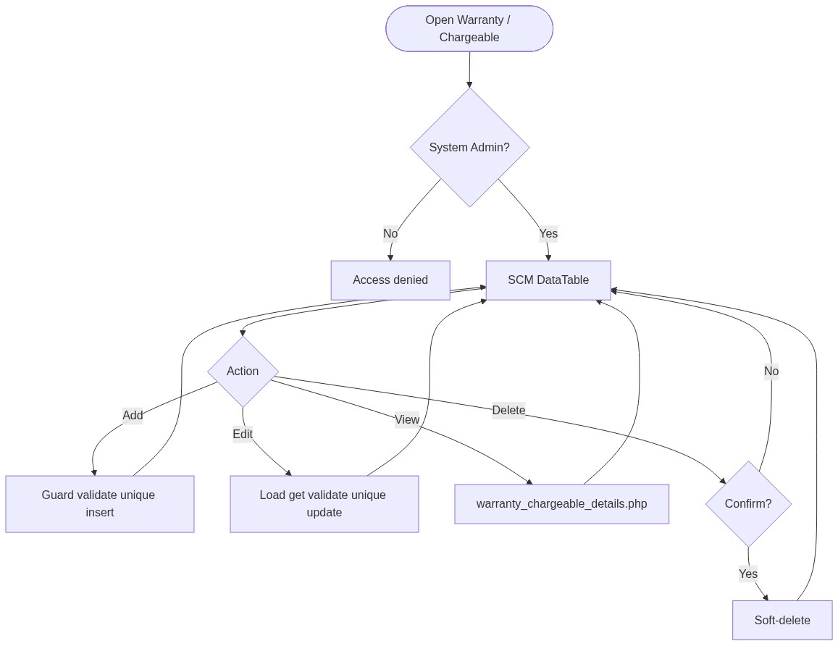
Figure 7 — Activity diagram
â”€â”€â”€â”€â”€â”€â”€â”€â”€â”€â”€â”€â”€â”€â”€â”€â”€â”€â”€â”€â”€â”€â”€â”€â”€â”€â”€â”€â”€â”€â”€â”€

12. Class / Module Diagram
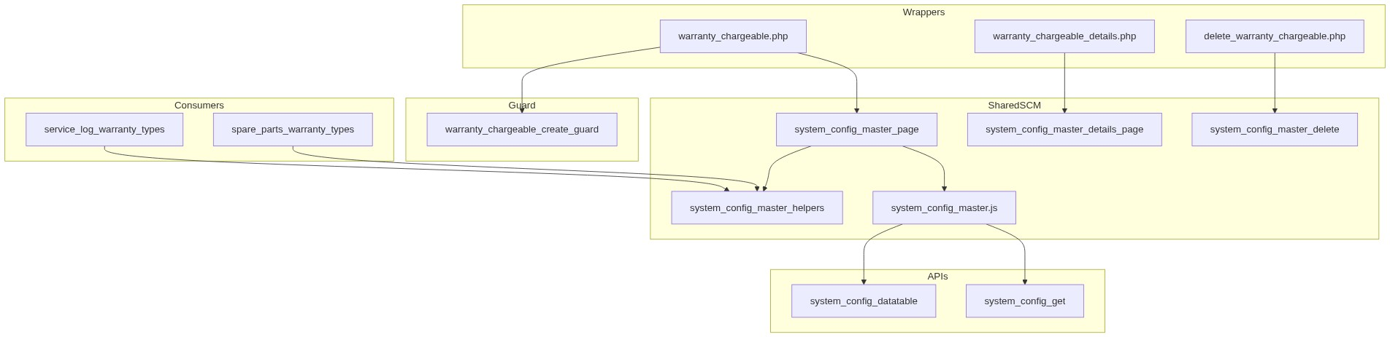
Figure 8 — Class / module diagram

12.1 Key functions
Function | Role
scm_registry / scm_config | Type → table/pages/labels
scm_safe_table | Whitelist table name
scm_from_post / scm_validate | Parse + validate
scm_name_exists | Uniqueness
scm_insert / scm_update / scm_soft_delete | Persist
scm_get_by_id / scm_get_active_names / scm_option_exists | Reads
scm_entry_actions / scm_page_js_config | UI/API wiring
warranty_chargeable_enforce_create_request | Create abuse guard
service_log_warranty_types / spare_parts_warranty_types | Consumer option wrappers
require_system_admin | Access gate

â”€â”€â”€â”€â”€â”€â”€â”€â”€â”€â”€â”€â”€â”€â”€â”€â”€â”€â”€â”€â”€â”€â”€â”€â”€â”€â”€â”€â”€â”€â”€â”€

13. Folder Structure
ComplaintManagement/
├── warranty_chargeable.php
├── warranty_chargeable_details.php
├── delete_warranty_chargeable.php
├── api/
│ ├── system_config_datatable.php
│ └── system_config_get.php
├── includes/
│ ├── system_config_master_helpers.php
│ ├── system_config_master_page.php
│ ├── system_config_master_details_page.php
│ ├── system_config_master_delete.php
│ ├── admin_access_helpers.php
│ ├── admin_api_guard.php
│ └── module_create_guards/
│ └── warranty_chargeable_create_guard.php
├── js/
│ └── system_config_master.js
├── storage/
│ └── request_abuse/warranty_chargeable/
└── docs/
└── LLD_Warranty_Chargeable_Module.md
â”€â”€â”€â”€â”€â”€â”€â”€â”€â”€â”€â”€â”€â”€â”€â”€â”€â”€â”€â”€â”€â”€â”€â”€â”€â”€â”€â”€â”€â”€â”€â”€

14. Error Handling
Layer | Pattern
Create guard fail | $_SESSION['error_message']; POST submit unset
Page POST | Inline / session success or error via SCM page
Delete | Session flash → warranty_chargeable.php
Details invalid | die('Invalid record.') / die('Warranty / Chargeable not found.')
APIs | JSON + HTTP 403/404
Create guard log | storage/request_abuse/warranty_chargeable/

14.1 Common messages
Message | When
Warranty / Chargeable saved successfully. | Create
Warranty / Chargeable updated successfully. | Update
Warranty / Chargeable deleted successfully. | Soft-delete
Failed to save warranty / chargeable. / Failed to update... / Failed to delete... | Persist fail
Warranty / Chargeable not found or already deleted. | Missing target
Warranty / Chargeable name already exists... | Unique violation
Invalid record. | Bad delete id
Access denied. System Admin privileges required. | Non-admin

â”€â”€â”€â”€â”€â”€â”€â”€â”€â”€â”€â”€â”€â”€â”€â”€â”€â”€â”€â”€â”€â”€â”€â”€â”€â”€â”€â”€â”€â”€â”€â”€

15. Security Considerations
Area | Control
Authorization | System Admin hard-gate on SCM pages + APIs
Soft-delete | Excluded from active queries and SL / SP options
Create abuse | Throttle, rate limit, payload size, monitor log
Table safety | scm_safe_table whitelist for datatable SQL
DB uniqueness | Partial unique index on lower(trim(name)) among non-deleted
CSRF | Not implemented on POST or GET delete
Delete method | GET soft-delete — CSRF-friendly; confirm only
PRG | Not used on create/update
Guard order gap | Create guard in wrapper can run before require_system_admin → non-admins may write throttle/abuse files
Option exists gap | scm_option_exists ignores status → inactive name can pass consumer server check if forced in POST
Length mismatch | Master VARCHAR(100) vs consumer VARCHAR(50)
Draft gap | Complaint SL draft may require warranty string without scm_option_exists (full SL save does check)
Denormalized names | Rename/delete orphans historical SL / SP values

â”€â”€â”€â”€â”€â”€â”€â”€â”€â”€â”€â”€â”€â”€â”€â”€â”€â”€â”€â”€â”€â”€â”€â”€â”€â”€â”€â”€â”€â”€â”€â”€

16. Audit Logs

16.1 Built-in field-level audit
Field | Behavior
created_by / created_at | On create
updated_at | On update / soft-delete
deleted_at | Soft-delete
Dedicated audit table | Not implemented
Create abuse log | storage/request_abuse/warranty_chargeable/abuse_monitor.log

â”€â”€â”€â”€â”€â”€â”€â”€â”€â”€â”€â”€â”€â”€â”€â”€â”€â”€â”€â”€â”€â”€â”€â”€â”€â”€â”€â”€â”€â”€â”€â”€

17. Test Cases

17.1 Functional
ID | Scenario | Expected
TC-01 | Non-admin opens Warranty / Chargeable | Denied
TC-02 | Create with empty name | Validation error
TC-03 | Create duplicate name (different case) | Rejected (app + DB unique)
TC-04 | Soft-delete then recreate same name | Allowed
TC-05 | Set status inactive | In admin list; not in SL / SP Select2
TC-06 | Soft-delete name used on SL / SP rows | Rows keep old string; dropdown omits it
TC-07 | Edit via pencil | Form filled from system_config_get
TC-08 | Delete confirmed | Soft-deleted; flash success
TC-09 | Create twice within 3 seconds | Throttle error
TC-10 | Create >20 in 15 minutes | Rate-limit error
TC-11 | Service Log submit without warranty | Warranty / Chargeable is required.
TC-12 | Spare Parts submit unknown name | Invalid Warranty / Chargeable selection.
TC-13 | Details with bad base64 id | Invalid record
TC-14 | Datatable type=warranty_chargeable as admin | Rows from warranty_chargeable_types
TC-15 | Name longer than 50 chars | May save on master but truncate/fail risk on SL / SP

â”€â”€â”€â”€â”€â”€â”€â”€â”€â”€â”€â”€â”€â”€â”€â”€â”€â”€â”€â”€â”€â”€â”€â”€â”€â”€â”€â”€â”€â”€â”€â”€

18. Assumptions & Dependencies

18.1 Assumptions
1. Role id 6 is System Admin.
2. Soft-delete is the only remove mechanism.
3. Service Log and Spare Parts are the primary runtime consumers.
4. Name string denormalization on SL / SP is intentional for historical display.
5. Shared SCM stack remains the implementation vehicle.
6. Document target stack Core PHP + MySQL; repo runs PostgreSQL.
7. Create-guard storage under storage/request_abuse/warranty_chargeable/ is writable.
8. Operational practice keeps option names ≤ 50 characters to match consumer columns.

18.2 Dependencies
Dependency | Purpose
SCM shared pages/helpers/JS/APIs | CRUD UI and persistence
admin_access_helpers / admin_api_guard | System Admin gate
rbac_helpers | Status options / validation / badges
Create-guard storage | Throttle state + abuse log
jQuery + DataTables + validate.js | List / form UX
Service Log / Spare Parts modules | Consumers of active names

â”€â”€â”€â”€â”€â”€â”€â”€â”€â”€â”€â”€â”€â”€â”€â”€â”€â”€â”€â”€â”€â”€â”€â”€â”€â”€â”€â”€â”€â”€â”€â”€

Appendix A — Success flashes
Event | Message
Create | Warranty / Chargeable saved successfully.
Update | Warranty / Chargeable updated successfully.
Delete | Warranty / Chargeable deleted successfully.

â”€â”€â”€â”€â”€â”€â”€â”€â”€â”€â”€â”€â”€â”€â”€â”€â”€â”€â”€â”€â”€â”€â”€â”€â”€â”€â”€â”€â”€â”€â”€â”€

Appendix B — Select2 control map
Screen | Control | Select2?
Admin status select | Native <select> | No
Service Log #serviceLogWarrantySelect | Select2 | Yes (consumer)
Spare Parts #sparePartsWarrantySelect / #slSparePartsWarrantySelect | Select2 | Yes (consumer)
IB / Complaint nested SL modal #ibServiceLogWarrantySelect | Select2 | Yes (consumer)

â”€â”€â”€â”€â”€â”€â”€â”€â”€â”€â”€â”€â”€â”€â”€â”€â”€â”€â”€â”€â”€â”€â”€â”€â”€â”€â”€â”€â”€â”€â”€â”€

Appendix C — SCM registry entry
Key | Value
Type | warranty_chargeable
Table | warranty_chargeable_types
Label | Warranty / Chargeable
Plural | Warranty / Chargeable Types
Page | warranty_chargeable.php
Submit key | submit_warranty_chargeable
Icon | bi-shield-check

â”€â”€â”€â”€â”€â”€â”€â”€â”€â”€â”€â”€â”€â”€â”€â”€â”€â”€â”€â”€â”€â”€â”€â”€â”€â”€â”€â”€â”€â”€â”€â”€

Appendix D — Create guard limits
Limit | Value
Max records per request | 1
Min interval between creates | 3 seconds
Max creates per window | 20
Window | 15 minutes

â”€â”€â”€â”€â”€â”€â”€â”€â”€â”€â”€â”€â”€â”€â”€â”€â”€â”€â”€â”€â”€â”€â”€â”€â”€â”€â”€â”€â”€â”€â”€â”€

Appendix E — Status vs consumer visibility
Value | Admin list | SL / SP options
active | Yes | Yes
inactive | Yes | No
Soft-deleted | No | No

â”€â”€â”€â”€â”€â”€â”€â”€â”€â”€â”€â”€â”€â”€â”€â”€â”€â”€â”€â”€â”€â”€â”€â”€â”€â”€â”€â”€â”€â”€â”€â”€

Appendix F — Consumer column map
Module | Column | Max length
Service Log | service_logs.warranty_chargeable | 50
Spare Parts | spare_parts_consumption.warranty_chargeable | 50
Master | warranty_chargeable_types.name | 100

â”€â”€â”€â”€â”€â”€â”€â”€â”€â”€â”€â”€â”€â”€â”€â”€â”€â”€â”€â”€â”€â”€â”€â”€â”€â”€â”€â”€â”€â”€â”€â”€
End of LLD — Warranty / Chargeable Module

